**What is Data Analysis?**

**process of inspecting, cleaning, transforming, and modeling data to uncover valuable insights.**

These skills encompass proficiency in **statistical analysis**, **data manipulation**using tools like **Python**or **R**, and the ability to create compelling [**data visualizations**](https://www.geeksforgeeks.org/data-visualization/data-visualization-and-its-importance/).

**Why Data Analyst?**

**Being a Data Analyst you will be working on real-life problem-solving scenarios and with this fast-paced, evolving technology, the demand for Data Analysts has grown enormously.**  competition is growing every day and companies require new methods to compete for their existence and that's what Data Analysts do.

* If you're someone who likes thinking out of the box then you are the perfect fit for this domain
* According to multiple reports, the demand for Data Analysts job are high VS the supply to the market is comparatively less and that's one of the reasons why people are shifting their career to Data Science. Till now, there are more than***28,000 job postings available in India and 414,000+ jobs are available worldwide.***

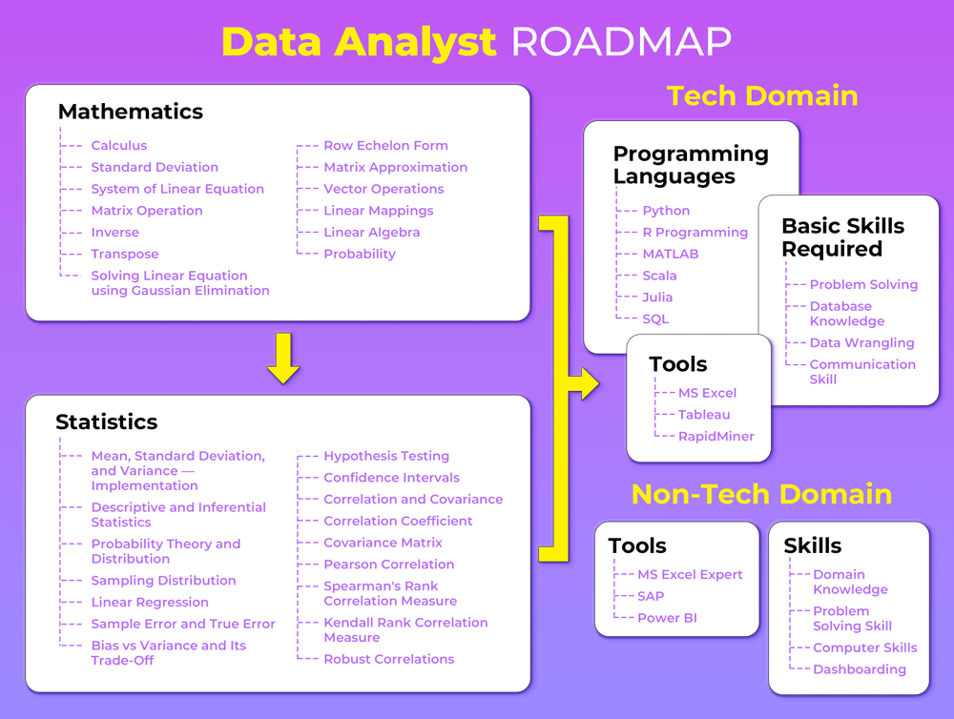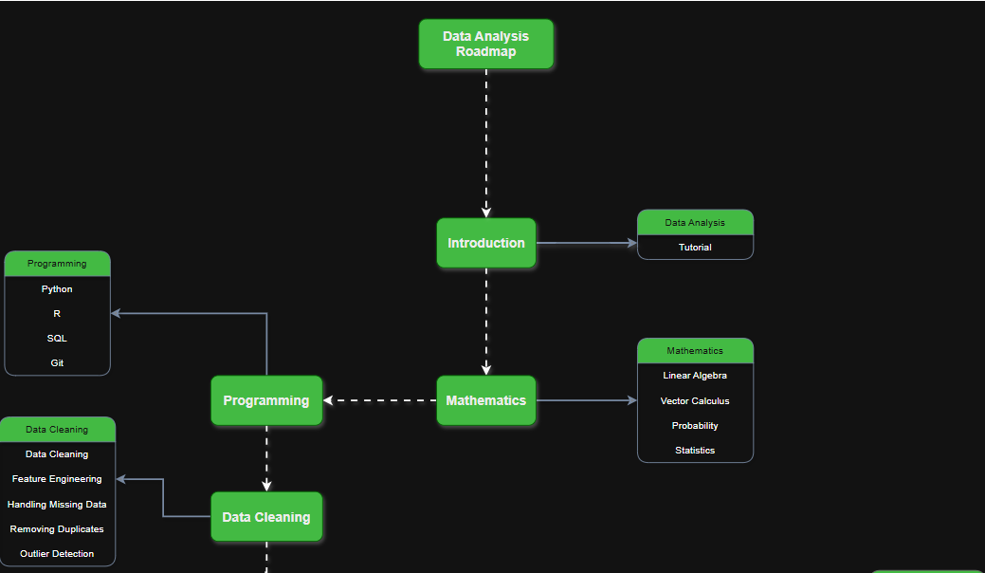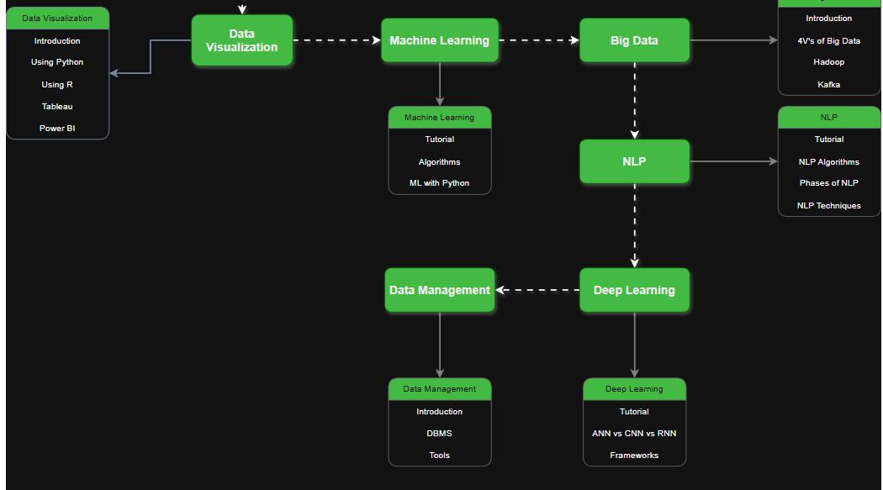

**Ya to excuses choose kar le, ya to apna 6–10 LPA ka package. Dono ek saath nahi milte.**

**💥 Brutal Truth:**

You want a **guaranteed job in 5 months**?  
Yes — **possible**. But not with half-effort.  
This isn’t college assignments. This is **career war**.

You don’t need to be *genius*.  
You just need:

* **Relentless consistency** (daily work, no skips)
* **Smart direction** (not just random YouTube)
* **Real projects + public proof (GitHub + LinkedIn)**

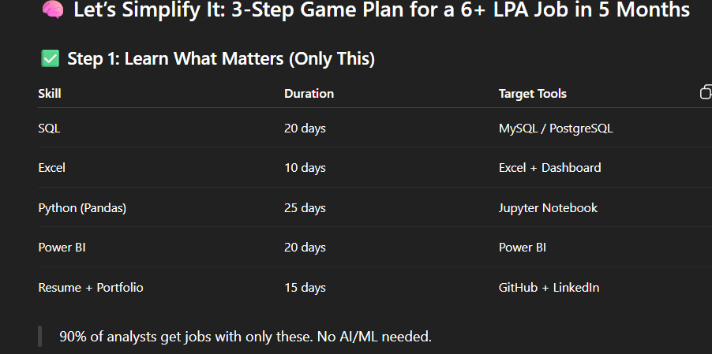

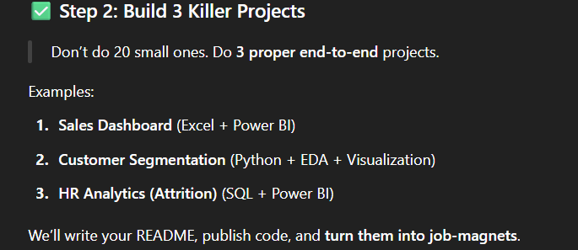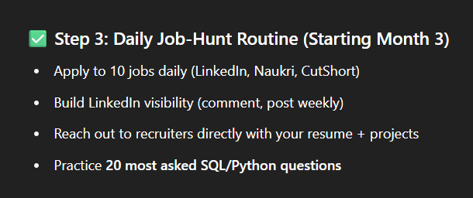

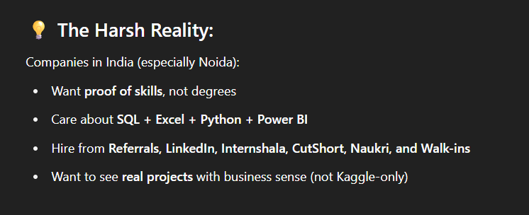

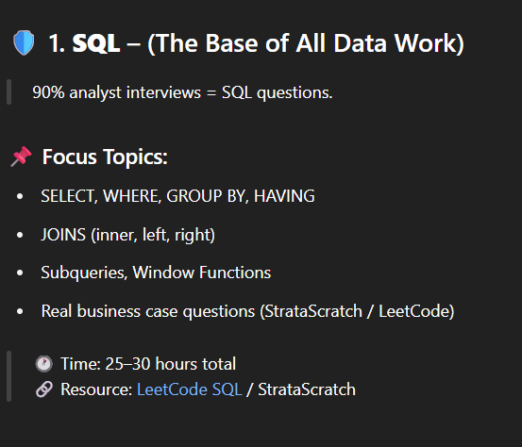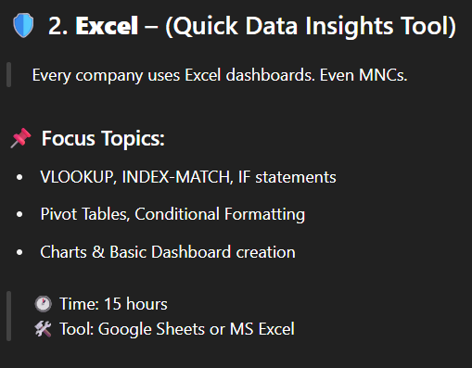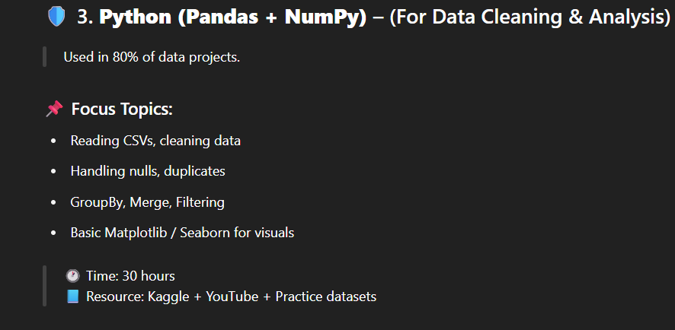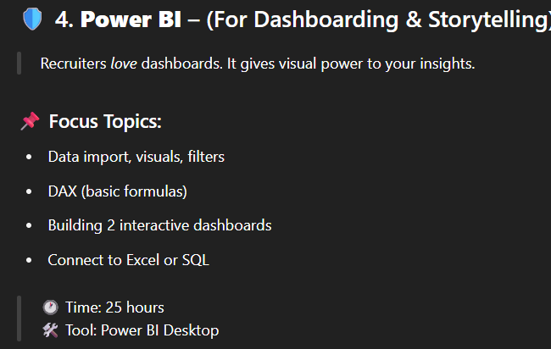

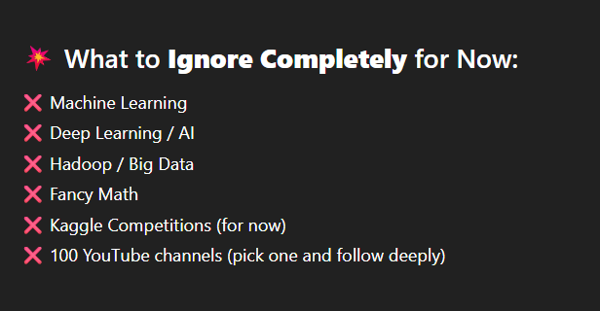

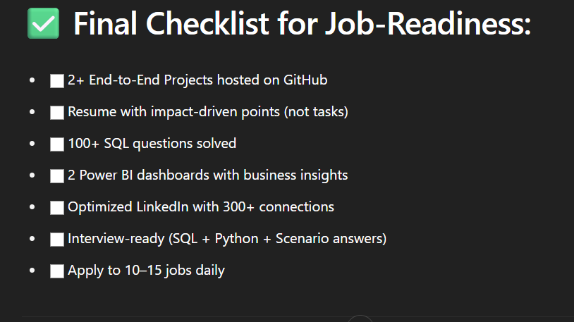

**1️⃣ SQL (Structured Query Language)**

💡 Used in almost 100% of analyst interviews.

**📚 Detailed Syllabus:**

**✅ Basics:**

* SELECT, FROM, WHERE, ORDER BY
* DISTINCT, LIMIT, BETWEEN, IN, NOT IN

**✅ Aggregations:**

* COUNT, SUM, AVG, MIN, MAX
* GROUP BY, HAVING (filtering aggregates)

**✅ JOINS:**

* INNER JOIN, LEFT JOIN, RIGHT JOIN, FULL JOIN
* SELF JOIN
* Multiple JOINS in single query

**✅ Subqueries & CTEs:**

* Scalar subqueries
* Correlated subqueries
* WITH clause (Common Table Expressions)

**✅ Advanced:**

* CASE WHEN, IF, COALESCE, NULL handling
* Window Functions: ROW_NUMBER, RANK, DENSE_RANK
* LEAD, LAG, PARTITION BY
* Views, Temporary Tables
* Index basics (just conceptual)

**✅ Practical Case Studies:**

* Sales reporting
* Retention and churn queries
* Cohort analysis
* Revenue trends

🎯 **Goal**: Solve at least **100 SQL problems** on:

* StrataScratch
* LeetCode SQL

**2️⃣ Excel / Google Sheets**

💡 Still a core tool in 90% of Indian companies.

**📚 Detailed Syllabus:**

**✅ Basics:**

* Data entry, formatting, cleaning
* Shortcuts & formula flow

**✅ Functions:**

* VLOOKUP, HLOOKUP, XLOOKUP
* IF, IFS, AND, OR, IFERROR
* INDEX-MATCH combo (important)

**✅ Aggregation & Analysis:**

* Pivot Tables & Pivot Charts
* Sorting & Filtering
* Conditional Formatting

**✅ Dashboards:**

* Interactive charts (Bar, Line, Pie)
* Slicers
* Dynamic ranges
* Dashboard design principles

🎯 **Goal**: Make at least **2 live dashboards** using Excel

**3️⃣ Python for Data Analysis (Pandas + NumPy + Matplotlib)**

💡 Used in all startups, product companies, analyst interviews.

**📚 Detailed Syllabus:**

**✅ Python Basics:**

* Variables, Data types (int, float, list, dict)
* Loops, Conditionals
* Functions, Lambda
* List & Dict Comprehensions

**✅ NumPy:**

* Arrays, Indexing
* Broadcasting
* Aggregation & math operations

**✅ Pandas:**

* Reading files (CSV, Excel)
* DataFrame creation, indexing, slicing
* Filtering, groupby, pivot_table
* Handling missing data (isnull, fillna, dropna)
* Merging / Joining dataframes
* Sorting, resetting index
* Time-series basics (optional)

**✅ Matplotlib / Seaborn:**

* Line, Bar, Pie, Histogram
* Boxplot, Heatmap
* Styling, labels, titles
* Subplots

🎯 **Goal**: Complete at least **3 full EDA (Exploratory Data Analysis) projects** using Pandas.

**4️⃣ Power BI (or Tableau)**

💡 Must-have skill for dashboarding & reporting.

**📚 Detailed Syllabus:**

**✅ Basics:**

* Data loading (Excel, SQL)
* Power BI interface, relationships
* Table vs Matrix vs Card visual

**✅ Visuals:**

* Bar, Line, Pie, Donut
* Slicers, Filters
* Map visualizations (geo-based)

**✅ DAX (Data Analysis Expressions):**

* Calculated columns
* Measures (SUM, COUNT, AVERAGE)
* IF, SWITCH, CALCULATE
* Time-intelligence basics (YTD, MTD, YoY)

**✅ Interactions:**

* Drill-down & drill-through
* Bookmarks & Page Navigation

**✅ Publishing:**

* Power BI Service (optional)
* Sharing dashboard links

🎯 **Goal**: Make 3 Power BI dashboards with real business insights (sales, HR, revenue)

**5️⃣ Business Intelligence & Analytical Thinking**

💡 This sets you apart. More than just technical skills.

**📚 Detailed Syllabus:**

**✅ KPIs & Metrics:**

* CAC (Customer Acquisition Cost)
* LTV (Lifetime Value)
* Churn Rate
* ARPU, MRR, ARR
* Retention rate

**✅ Case Studies (Prepare for Interviews):**

* “Why is user engagement dropping?”
* “How would you improve revenue?”
* “How to analyze sales dip in a region?”

**✅ Storytelling with Data:**

* Insight > Not just numbers
* Data → Problem → Insight → Action
* Using visuals to communicate ideas

**6️⃣ Portfolio + Resume + LinkedIn**

💡 This **gets you hired**.

**📚 Portfolio Must-Haves:**

* 2 EDA Python Projects on GitHub (with ReadMe)
* 2 Dashboards (Power BI or Excel) with screenshots
* 1 Resume-Linked Mini Case Study (PDF)
* Optimized Resume (ATS keywords)
* LinkedIn: Public posts of your dashboards + journey

🎯 **Goal**: Become “searchable” by recruiters on LinkedIn.

**📦 Optional (Advanced Topics for Later)**

| **Topic** | **When to Learn** |
| --- | --- |
| Machine Learning | After getting the job |
| Statistics & Probability | Light touch in Month 2 |
| Big Data Tools | Not needed for 6 LPA jobs |
| Python OOP | Only for data engineer roles |